**Signed 8-bit node test multiplication and summing for two inputs**

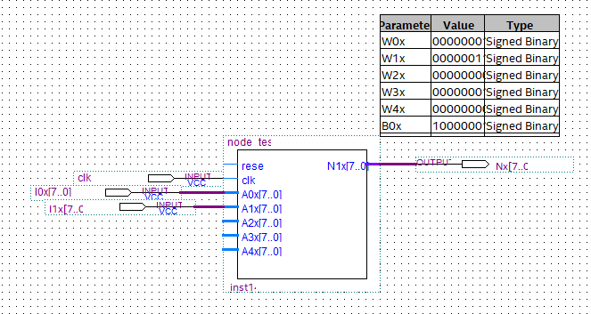

A+B case: (1*1)+(1*3)=4

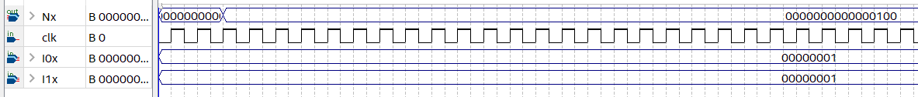

A-B B>A case: (1*1)+(-1*3)=-2



A-B B<A: 4-3=1

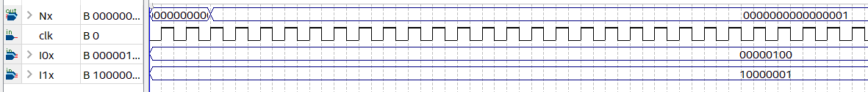

B-A B>A: -1+3=2

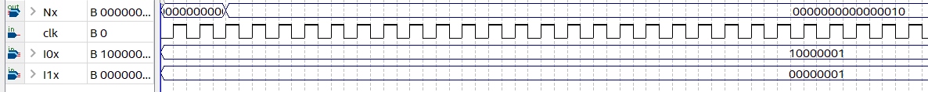

B-A B<A: -4+3= -1

